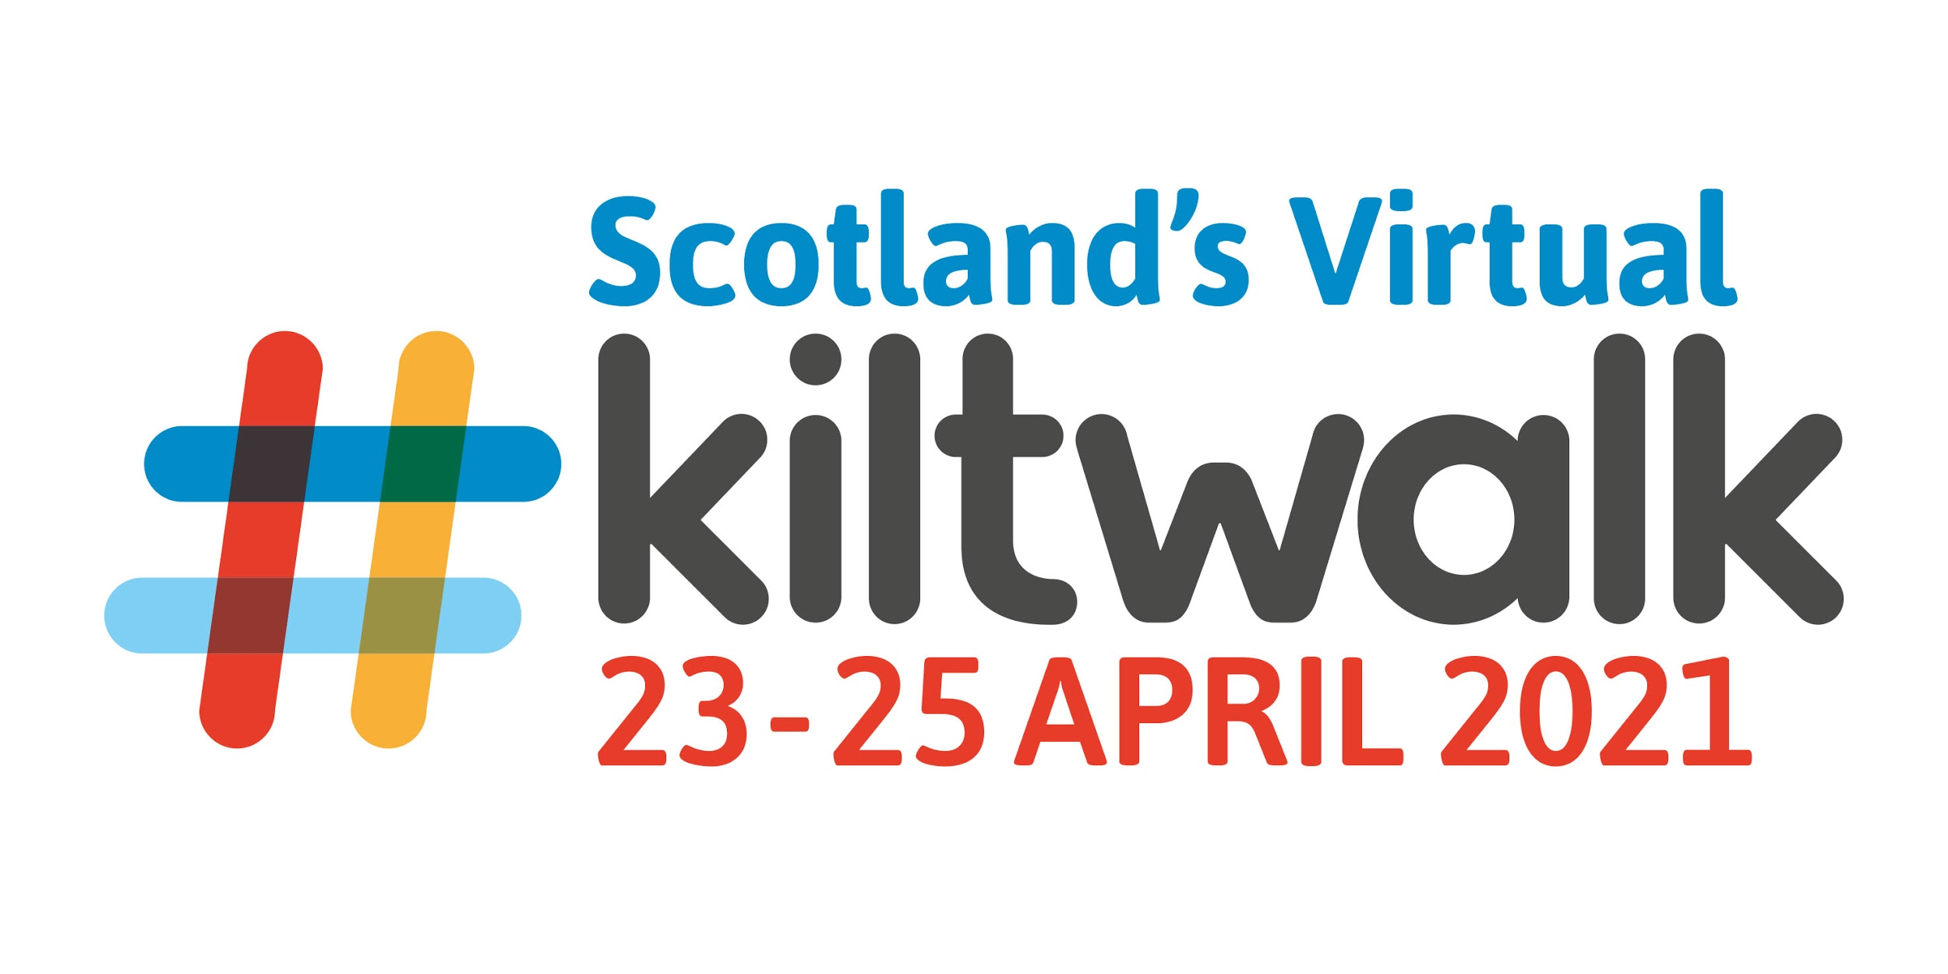
Thank you so much for thinking about or taking part in our Global Kiltwalk.

If you need ideas on what to put on your fundraising page you have come to the right place below is an extract you can just cut copy and paste and then add your personal story

Hi! I am taking on a Kilt walk to raise funds Stepping Out. Stepping Out is a mental health charity working in East Lothian in Scotland who work with adults and families offering a wide range of individualised mental health support. They are passionate about improving mental health in the community and understanding how mental health effects us all. Covid has brought exceptional challenges and the demand for mental health services has never been greater. Stepping Out have continued to work throughout the pandemic responding in a creative and flexible way to meet their members needs. The pressures on funding has been challenging to meet. The great thing about the virtual kiltwalk is that it is so inclusive and has been built into a community activity rather than an individual one. It allows people to set their own target and to do as much as they are able. Last year our youngest walker was 2 and walked 1K for us and our eldest was over 70!
All research confirms that the following things promote better mental health: -being out in nature -helping others -having a purpose/goals -exercise -a sense of community/belonging. Every penny I raise will be topped up by 50% thanks to the generosity of Sir Tom Hunter and The Hunter Foundation. Any donation you can spare will mean the world to me and my chosen charity Stepping Out. Thank you.

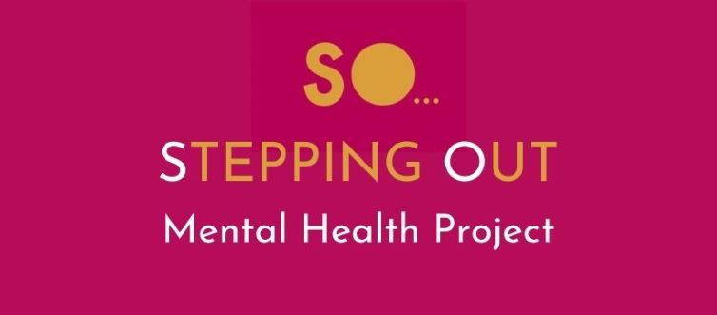

Don’t forget to join our Facebook page and keep us informed of how you are getting on
And if you need any further information please just contact us all details and contact numbers or on the contacts page on the website.

